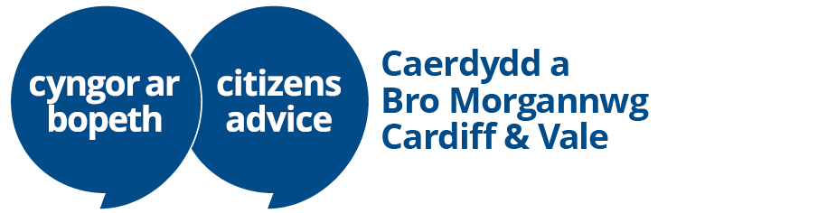

Debt Team Leader Job Description

What you can expect

You will be responsible for the operational delivery of our advice services to clients, leading a diverse team of Debt Caseworkers to deliver high-quality advice.

Responsibilities
All the responsibilities that we’ll trust you with

 | Team Leader responsibilities  The work you do can have a huge impact on your team and contribute to CACV’s success

- You will foster a spirit of teamwork, open communication and inclusivity supporting your team members to achieve their full potential
- You will lead, coach, coordinate, and motivate your team to achieve key performance targets, including call volumes and advice quality standards
- You will plan and manage operational resources in cooperation with other Team Leaders to ensure effective service delivery
- You will implement appropriate performance management solutions targeted specifically at the issues identified
- You will report performance information to the senior management team, identifying areas for improvement and detailing your proposed solutions

 | Learning & development  We are committed to helping you perform to the best of your ability

- We will support your development by providing appropriate training and coaching
- You will be proactive in your learning and identify your professional development needs

 | Being an employee of CACV  We value all our employees, and we set high standards

- You will contribute to the wellbeing of your colleagues by being respectful of others
- You will demonstrate a commitment to our aims and principles, adhere to our policies to protect the integrity and reputation of the organisation
- You will maintain professional standards

This job description is intended as a guide only. It is not exhaustive and does not constitute a term and condition of employment.

What we’re looking for
Your areas of knowledge and experience

We are looking for someone with proven experience in leading, motivating and managing the performance of teams in a client/customer-focused environment. In addition, you must:

- Be able to use a range of management techniques to obtain high levels of performance from your team members
- Have excellent organisational and time management skills to manage the varying demands of a team and prioritise your work
- Have excellent verbal, written and interpersonal communication skills with an ability to think critically
- Have a high level of resilience, enabling you to deal with challenging situations
- Be able to work collaboratively with fellow Team Leaders and Senior Managers
- Be accepting of feedback from the Advice Services Manager, given to help you perform to the best of your abilities
- Be adaptable so you can respond to changing organisational needs

